

**ASBAT EXAMINATIONS BOARD**

**END OF TERM 2 EXAMINATION -2024**

**LITERACY 1A - P.2**

Name: _______________________________________

Class: __________________________________________

SECTION A: 2 MARKS EACH

1. Mention the body part which supports the neck.

_____________________________________________________________

1. What is the best food for babies?

_____________________________________________________________

1. How do snakes move?

_____________________________________________________________

1. Name any one thing found in the kitchen.

_____________________________________________________________

1. Identify the garden tool used for transplanting seeds from the nursery bed.

_____________________________________________________________

1. Which common disease is spread by mosquitoes?

_____________________________________________________________

1. Write down any two childhood diseases.

(i)____________________________ (ii)__________________________

1. Name the habitat for monkeys.

_____________________________________________________________

1. What are flowering plants?

_____________________________________________________________

1. Name these objects which cause accidents.

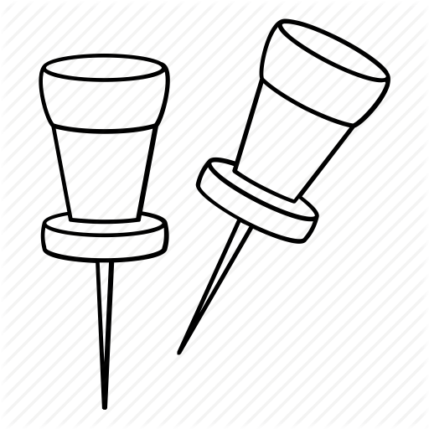_____________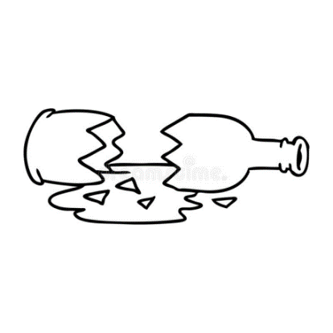_____________________

1. Why do we wash our hands with soap after visiting a toilet?

____________________________________________________________

1. Identify the disease this child is suffering from.

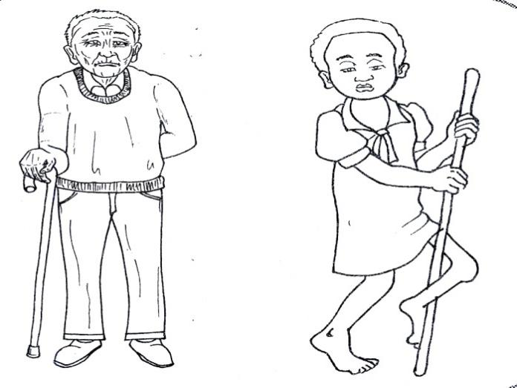____________________________________________________

1. Name the best season for growing crops.

____________________________________________________________

1. How is the tongue important in your mouth?

____________________________________________________________

1. Mention any one room found in the house.

____________________________________________________________

1. Draw and name two items used to keep places clean.

|  |  |
| --- | --- |
|  |  |
|  |  |

1. How does a bee protect itself?

____________________________________________________________

**SECTION B (60marks)**

1. (a) What is a seedling?

____________________________________________________________

(b)Write down two conditions necessary for seed germination.

(i)__________________________________________________________

(ii)__________________________________________________________

(c)In the space below, draw a bean seed.

1. (a) How are the following useful on the body?
2. Skin_____________________________________________________
3. Ears_____________________________________________________
4. Legs____________________________________________________

(b)Mention any two ways how people keep their bodies clean.

(i)___________________________________________________________

(ii)___________________________________________________________

1. (a) List down any three things found in the first aid box.

(i)___________________________ (ii)____________________________

(iii)__________________________________________________________

(b)Write one reason why people are given first aid.

____________________________________________________________

1. (a) What is the main source of food?

____________________________________________________________

(b)Give any two examples of food eaten by people.

(i)_________________________ (ii)__________________________

(c)Mention two ways we can keep food safe.

(i)__________________________________________________________

(ii)__________________________________________________________

1. **Match correctly.**

Malaria rabid dogs

Sleeping sickness houseflies

Rabies cockroach

Diarrhea mosquitoes

Trachoma tsetsefly

1. **Name these things we use to wash hands**

________________ 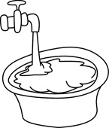_________________

(b)When should people wash their hands?

_____________________________________________________________

1. **Write the animal movements**

(i)Baby______________________ (ii)Cow ___________________

(iii)Fish ____________________ (iv)Caterpillar ________________

(v)Grasshopper____________________________________________

1. **(a) Name the life cycle below.**



(b)Give any two insects which undergo the above life cycle.

(i)___________________________ (ii)___________________________

1. (a) What is wind?

____________________________________________________________

(b)Write down two uses of wind to people.

(i)__________________________________________________________

(ii)__________________________________________________________

(c)How is too much wind dangerous to a farmer?

____________________________________________________________

1. (a) Mention any three examples of harmful insects

(i)____________________________ (ii)________________________

(iii)___________________________

(b)Why are houseflies called harmful insects?

____________________________________________________________

1. (a) What are non flowering plants?

____________________________________________________________

(b)Why are pines grouped under non flowering plants?

____________________________________________________________

(c)Identify two uses of flowers to people.

(i)__________________________________________________________

(ii)__________________________________________________________

1. **Name these wild animals below.**

|  |  |  |  |
| --- | --- | --- | --- |
| \\BIGZEE\Users\Public\Esther\New folder\elep.jpg | http://www.illustrationsof.com/royalty-free-monkey-clipart-illustration-1212558.jpg | Image result for lion images clip art black and white | Image result for snake images clip art black and white |
|  |  |  |  |

1. **Draw and name four things found in the kitchen.**

|  |  |  |  |
| --- | --- | --- | --- |
|  |  |  |  |
|  |  |  |  |

1. **Write “true” or “false” at the end of the sentence.**
2. Domestic birds are also called poultry.______________
3. Butter is got from skin_______________________________
4. A monkey chatters. ________________________________

**END**